Name: Pargat Singh
Batch: A2
Roll No.: 16010121045
Date: 12/01/2022
CO 5: Understand and apply basic concepts of spectroscopy and electro-analytical technique in characterizing chemical compounds.

EXPERIMENT 10: Interpretation of IR spectra

FUNCTIONAL GROUPS AND IR TABLES:
Characteristic IR Absorption Frequencies of Organic Functional Groups
Functional Group | Type of Vibration | Characteristic Absorptions (cm-1) | Intensity
Alcohol
O-H | (stretch, H-bonded) | 3200-3600 | strong, broad
O-H | (stretch, free) | 3500-3700 | strong, sharp
C-O | (stretch) | 1050-1150 | Strong
Alkane
C-H | stretch | 2850-3000 | Strong
-C-H | bending | 1350-1480 | Variable
Alkene
=C-H | stretch | 3010-3100 | Medium
=C-H | bending | 675-1000 | Strong
C=C | stretch | 1620-1680 | Variable
Alkyl Halide
C-F | stretch | 1000-1400 | Strong
C-Cl | stretch | 600-800 | Strong
C-Br | stretch | 500-600 | Strong
C-I | stretch | 500 | Strong
Alkyne
C-H | stretch | 3300 | strong,sharp
 | stretch | 2100-2260 | variable, not present in symmetrical alkynes
Amine
N-H | stretch | 3300-3500 | medium (primary amines have two bands; secondary have one band, often very weak)
C-N | stretch | 1080-1360 | medium-weak
N-H | bending | 1600 | Medium
Aromatic
C-H | stretch | 3000-3100 | Medium
C=C | stretch | 1400-1600 | medium-weak, multiple bands
Analysis of C-H out-of-plane bending can often distinguish substitution patterns
Carbonyl | Detailed Information on Carbonyl IR
C=O | stretch | 1670-1820 | Strong
(conjugation moves absorptions to lower wave numbers)
Ether
C-O | stretch | 1000-1300 (1070-1150) | Strong
Nitrile
CN | stretch | 2210-2260 | Medium
Nitro
N-O | stretch | 1515-1560 & 1345-1385 | strong, two bands

IR Absorption Frequencies of Functional Groups Containing a Carbonyl (C=O)
Functional Group | Type of Vibration | Characteristic Absorptions (cm-1) | Intensity
Carbonyl
C=O | stretch | 1670-1820 | Strong
(conjugation moves absorptions to lower wave numbers)
Acid
C=O | stretch | 1700-1725 | Strong
O-H | stretch | 2500-3300 | strong, very broad
C-O | stretch | 1210-1320 | Strong
Aldehyde
C=O | stretch | 1740-1720 | Strong
=C-H | stretch | 2820-2850 & 2720-2750 | medium, two peaks
Amide
C=O | stretch | 1640-1690 | Strong
N-H | stretch | 3100-3500 | unsubstituted have two bands
N-H | bending | 1550-1640
Anhydride
C=O | stretch | 1800-1830 & 1740-1775 | two bands
Ester
C=O | stretch | 1735-1750 | Strong
C-O | stretch | 1000-1300 | two bands or more
Ketone
acyclic | stretch | 1705-1725 | Strong
cyclic | stretch | 3-membered - 1850  4-membered - 1780  5-membered - 1745  6-membered - 1715  7-membered - 1705 | Strong
,-unsaturated | stretch | 1665-1685 | Strong
aryl ketone | stretch | 1680-1700 | Strong

1.
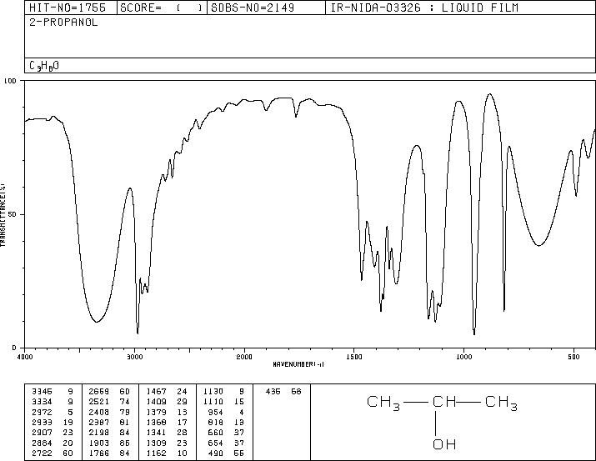
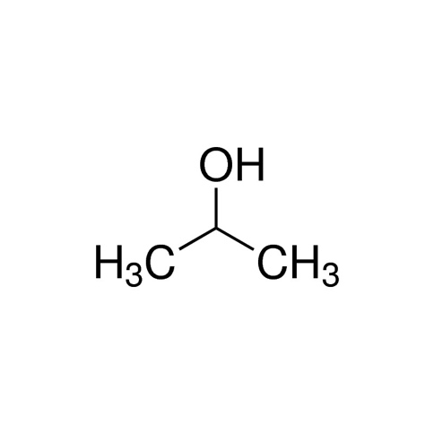

Sr.No | Observation  Frequency | Frequency  Range | Type of  Vibration | Intensity
1. | 3345,3334 | 3200-3600 | O-H | Strong, broad
2. | 2972,2845 | 2850-3000 | C-H | Strong
3. | 1740,1720 | 1740-1720 | C=O | Strong
4. | 1130,1110 | 1070-1150 | C-O | Strong
ISOPROPYL ALCOHOL
The number of atoms in C₃H₈O = 12
The molecule is ionic.
Thus, total number of vibrational moles = 3N-5
= 3(12)-5 =31
2.
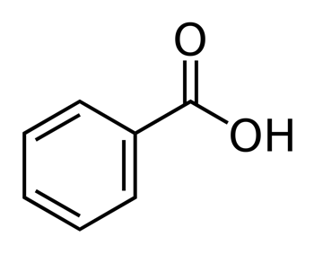
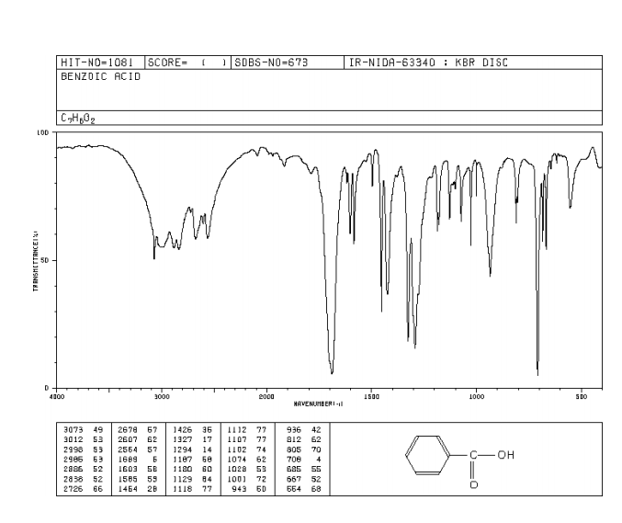

Sr.No | Observation  Frequency | Frequency  Range | Type of  Vibration | Intensity
1. | 3500,2500 | 2200-3600 | O-H(stretch) | Strong, sharp
2. | 2800,2500 | 2500-3300 | C-H | Strong, very broad
3. | 1685,1792 | 1670-1820 | C=O | Strong
4. | 934 | - | C-H | Medium
BENZOIC ACID
The number of atoms in C₇H₆O₂ = 15
The molecule is non polar.
Thus, total number of vibrational moles = 3N-5
= 3(15)-5 =40

3.
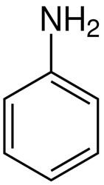
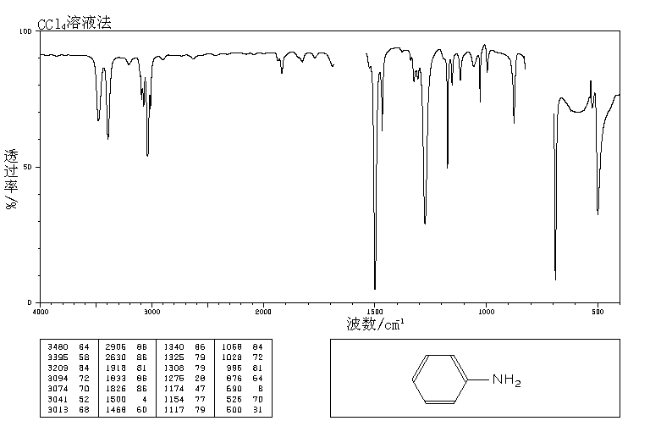
C6H7N
Sr.No | Observation  Frequency | Frequency  Range | Type of  Vibration | Intensity
1 | 3442,3360 | 3300-3500 | N-H(primary) | Medium
2 | 1281 | 1080-1360 | C-N(stretch) | Medium weak
3 | 1619 | 1600 | N-H(Bend) | Medium
ANILINE
The number of atoms in C₆H₇N = 14
The molecule is polar.
Thus, total number of vibrational moles = 3N-5
= 3(14)-5 =37
4.
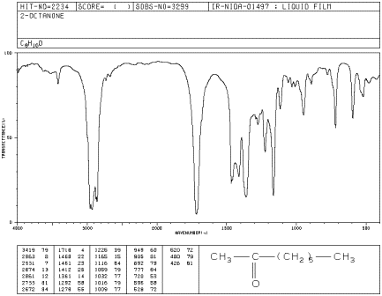
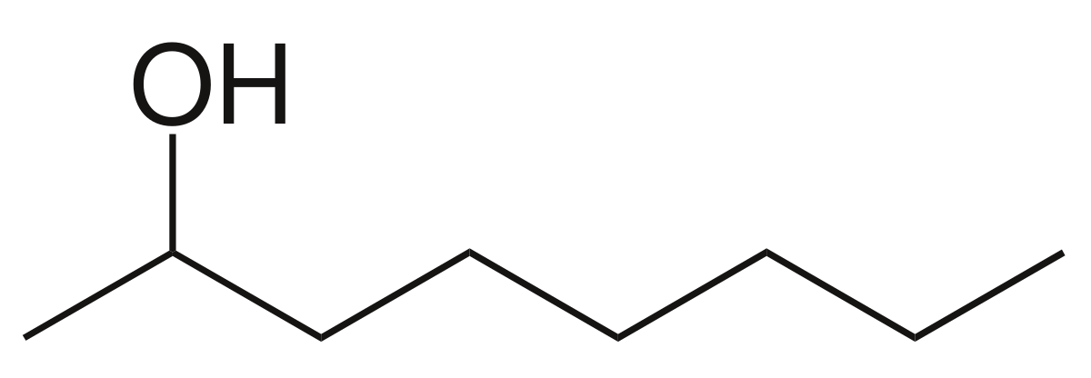
Sr.No | Observation  Frequency | Frequency  Range | Type of  Vibration | Intensity
1. | 3230,3500 | 3300 (Sharp) | O-H | Strong, broad.
2. | 2950,2850 | 2850-3000 | C-H | Strong
3. | 1075,1050 | 1050-1150 | C-O & C-H | Strong(stretch)
4. | 500,700 | 675-1000 | =C-H | Strong
OCTANOL
The number of atoms in C₈H₁₆O = 23
The molecule is polar.
Thus, total number of vibrational moles = 3N-5
= 3(23)-5 = 64

5.
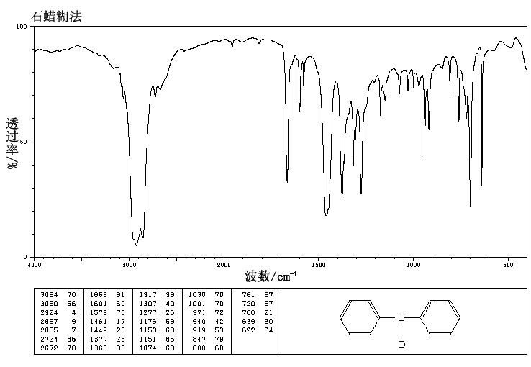
 C₁₃H₁₀O 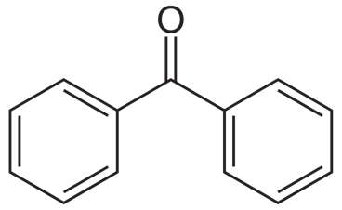
Sr.No | Observation  Frequency | Frequency  Range | Type of  Vibration | Intensity
1. | 1656,1601 | 1705-1725 | C=O | Strong
2. | 1669,1461,1579 | 1400-1600 | C=C | Variable
3. | 3060,3084 | 3000-3100 | C=C | Variable
4. | 2724,2855 | 2820-2860 & 2720-2750 | =C-H | Medium, two peaks
BENZOPHENONE
The number of atoms in C₁₃H₁₀O = 24
The molecule is non polar.
Thus, total number of vibrational moles = 3N-5 = 3(24)-5 = 67

